|  |  |  |  |
| --- | --- | --- | --- |
|  | | | |
| **PBT2/EEEENQP/1221/A 02-MAR-2022** | | | |
| **PREBOARD EXAMINATION-SET-2 (2021-2022)**  **EEE CONSORTIUM** | | | |
| **Subject: ENGLISH CORE**  **Grade: 12** | Max. Marks:40Time:2 HRS | | |
| **Name:** | | **Section:** | **Roll No:** |

***General Instructions:***

*1.The Question Paper contains THREE sections-READING, WRITING and LITERATURE.*

*2.Attempt questions based on specific instructions for each part.*

**1. Read the passage given below and answer the questions that follow. [8 marks]**

1 The political distemper of our times has crowded out of the space for discussion issues of long term consequence. In higher education, decisions are being taken that will affect the lives of millions of students. One such decision is Delhi University’s decision to conduct admissions using either a Central Universities Entrance Exam or its own entrance exam. The decision has been announced without detailing the nature, character and purpose of this exam. Universities need to reassess their methods from time to time. But this decision seems to be only half thought through. Changing the admissions criteria a few months before next year’s admissions smacks of callous disregard for students, especially in an era of Covid disruptions. A momentous decision like this needs to be announced at least a couple of years in advance.

2 But there is also no adequate explanation for exactly what problem this test is meant to solve. The immediate context of the decision was the fact that a disproportionately large number of students from states like Kerala were getting admission. Somehow, this exam is meant to create a level playing field. The registrar’s public explanation went: “In the past few years, we have seen students getting exorbitant marks, which in turn was leading to very high cut-offs. The entrance exam from this year will bring some relief to students. The pressure of high cut-offs will not be there. They can focus on specific subjects for preparation.”

3 These rationales are misleading. Cut-offs have become incredibly high. But to think that a separate entrance exam is a solution to that problem and will bring relief to the students defies logic. It adds the burden of yet another exam on the students. You now have a situation where students can excel at school and boards, but will have virtually no place to go without the burden of more exams. Although school will remain a qualifying criterion, its importance will be diminished. The pressure on Delhi University is the pressure of numbers; the demand is high and the number of top colleges is very small. The pressure to get into the top ranks or of percentiles of the exams will still remain. This is a country wherein a range of exams marks are calculated to the seventh decimal place to decide who will get selected. Every single place where we have an exam, from IIT to CLAT, is pressure ridden because of the law of numbers. So the idea that this exam will be a relief is strange.

**Based on your understanding of the passage, answer ANY EIGHT questions from the nine given below. 8M**

1. Which decision is the author talking about?’
2. Mention any two flaws of this decision.
3. State the reason given by the authorities for this decision.
4. How are the students going to be affected by this move?
5. Give the synonym of ‘enormous’ (Paragraph 2)
6. What do you understand by the statement, “This is a country wherein a range of exam marks are calculated to the seventh decimal place to decide who will get selected”.
7. Why do you think that this idea will not provide any relief?
8. What does the author mean by the phrase ‘smacks of callous disregard’?
9. Find a word from paragraph 3 which means the same as, ‘set of reasons’.

**2. Read the passage given below and answer the questions that follow 6M**

Land-use Changes in India

1 Land-use in a region, to a large extent, is influenced by the nature of economic activities carried out in that region. However, while economic activities change over time, land, like many other natural resources, is fixed in terms of its area. At this stage, one needs to appreciate three types of changes that an economy undergoes, which affect land-use.

2 The size of the economy (measured in terms of value for all the goods and services produced in the economy) grows over time as a result of increasing population, change in income levels, available technology and associated factors. As a result, the pressure on land will increase with time and marginal lands would come underuse.

3. Secondly, the composition of the economy would undergo a change over time. In other words, the secondary and the tertiary sectors usually grow much faster than the primary sector, specifically the agricultural sector.

4. Thirdly, though the contribution of agricultural activities reduces over time, the pressure on land for agricultural activities does not decline. The reasons for continued pressure on agricultural land are:

a). In developing countries, the share of the population dependent on agriculture usually declines much more slowly compared to the decline in the sector’s share in GDP.

b). The number of people that the agricultural sector has to feed is increasing day by day.

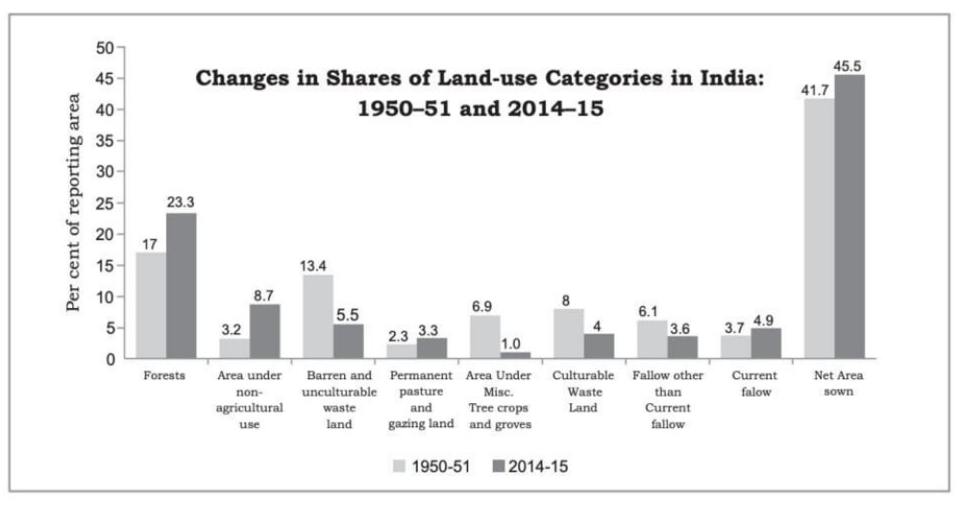

5. India has undergone major changes within the economy over the past four or five decades, and this has influenced the land-use changes in the country. There are two points that you need to remember before you derive some meaning from this figure. Firstly, the percentages shown in the figure have been derived with respect to the reporting area. Secondly, since even the reporting area has been relatively constant over the years, a decline in one category usually leads to an increase in some other category.

**Based on your understanding of the passage, answer ANY SIX questions from the seven given below. 6M**

1. What factors lead to an increase in the size of the economy?
2. How does the composition of the economy in developing nations undergo a change?
3. What does the land-use in a region, to a large extent, depend upon?
4. With reference to the given bar graph, what is the proportion of land occupied by forests in

the year 1950-51 and 2014-15?

1. Since the past, how many years has India undergone major changes within the economy?
2. What does the use of the phrase ‘marginal lands would come under use.’ suggest in the context of the writer’s viewpoint?
3. According to the data, which two factors are responsible for the betterment of any available category?

|  |
| --- |
| **SECTION B -WRITING 8M** |

3. You are Namita, residing in Mumbai. Your friend is hosting a reunion party at his/her residence on 15 Feb 2022 and has extended an invite to you. Draft a reply of acceptance, in not more than 50 words.

**3**

|  |
| --- |
| **4. Attempt ANY ONE from A and B given below. 5** |

1. You are Shadraf/Sanu, residing at 24, Bal Gangadhara Road, Neyveli. You come across the following classified advertisement in a local daily. Write a letter, in about 120-150 words, applying for the position.

|  |
| --- |
| **SITUATION VACANT**  **WANTED** committed volleyball coach, aged below 35 years, to train underprivileged children in Nasik area, for three hours per week. Previous experience and excellent track record essential. Apply within 7 days to The Coordinator, Play to win-Volleyball camp, Nasik. |

**OR**

A recently concluded 4-day Innovative Confluence organized by Kendriya Vidyalaya, New Delhi, was highly appreciated by the District Collector, Shri P. Shiv Prasad. As a staff reporter of ‘The Delhi Chronicle’, write a report about this in 120-150 words covering all the details of the programme.

**SECTION C- LITERATURE 18M**

**Q5. Attempt ANY FIVE of the six questions given below, within 40 words each. (2x5=10)**

i. Explain the symbolic significance of the ‘tigers’ in ‘Aunt Jennifer’s Tigers’.

ii. Keats has used the poem ‘A Thing of Beauty’ to elaborate and validate his philosophy ‘Beauty is truth, truth beauty.’- Elucidate.

iii. Mahatma Gandhi agreed to a settlement of 25 percent refund to the farmers. Do you support his decision? Give reasons for your answer.

iv. Comment on the appropriateness of the title ‘Should Wizard Hit Mommy?”.

v. Mr. Lamb was an excellent counselor. What was unique about his counselling, that he could influence Derry and change his perspective of life in such a short time?

vi. Do you agree with the peddler’s philosophy of rattrap? Give reasons for your opinion.

|  |
| --- |
| **6. Answer ANY TWO of the following in about 120-150 words each. (2x4=8)** |
| 1. How does Keats’ poem, A Thing of Beauty appeal to the mind and stimulate the senses? Write your answer in about 120-150 words. |

.

1. Evans Tries an O-level places clues at strategic points and leads the governor and the reader on a wild goose chase. Substantiate with reference to the text, in about 120-150 words.
2. Plays have certain features like plot, characters, dialogue, setting, conflict, and resolution, Examine “On the Face of It” in line with this statement, in about 120-150 words.

***